CHEMISTRY
UNIT 2 only
2024
MARKING GUIDE

Structure of this paper

Section | Number of questions available | Number of questions to be answered | Suggested working time  (minutes) | Marks available | Percentage of exam
Section One  Multiple-choice | 25 | 25 | 30 | 25 | 25
Section Two  Short answer | 8 | 8 | 50 | 61 | 35
Section Three  Extended answer | 4 | 4 | 70 | 69 | 40
 |  |  |  | Total | 100

Section One: Multiple-choice 25% (25 marks)

1 | a □ b □ c □ d ■ |  | 6 | a □ b ■ c □ d □ |  | 11 | a □ b □ c ■ d □
2 | a □ b ■ c □ d □ |  | 7 | a ■ b □ c □ d □ |  | 12 | a □ b □ c □ d ■
3 | a □ b ■ c □ d □ |  | 8 | a □ b ■ c □ d □ |  | 13 | a □ b □ c ■ d □
4 | a □ b □ c □ d ■ |  | 9 | a □ b ■ c □ d □ |  | 14 | a □ b □ c □ d ■
5 | a ■ b □ c □ d □ |  | 10 | a □ b □ c ■ d □ |  | 15 | a □ b ■ c □ d □

16 | a □ b ■ c □ d □ |  | 21 | a ■ b □ c □ d □
17 | a □ b □ c ■ d □ |  | 22 | a □ b ■ c □ d □
18 | a □ b ■ c □ d □ |  | 23 | a □ b □ c ■ d □
19 | a □ b □ c ■ d □ |  | 24 | a □ b ■ c □ d □
20 | a ■ b □ c □ d □ |  | 25 | a □ b □ c ■ d □

Section Two: Short answer 35% (61 marks)

Question 26 (7 marks)

Consider the organic compound below.

(a) Give the IUPAC name for this compound. (1 mark)

- 2-chlorobutane

(b) Name the reactants that you would mix together to produce this compound by; (4 marks)

An addition reaction. | Hydrogen chloride / hydrochloric acid (1)  But-1-ene / But-2-ene (1)
A substitution reaction. | Chlorine (1)  Butane (1)

(c) Which of the reaction types in part (b) would require the presence of a catalyst? Name the catalyst. (2 marks)

- Substitution reaction
- UV light

Question 27 (8 marks)

Two positions of the same syringe are shown.
CO₂
CO₂
X
Y
A syringe shown in position X contains 540 mL of CO₂ at STP and is
then compressed to a smaller volume, as in position Y at the same
temperature.

- Explain why the pressure in the cylinder has changed in going from position X to position Y in terms of the kinetic theory of gases. (2 marks)

Description | Marks
As the volume of the cylinder is reduced the spacing between the particles becomes less but the speed remains constant. | 1
The particles now have less distance to travel between collisions and so the collision rate with the walls increases, which increases the force on the wall and hence the pressure will be greater. | 1
Total | 2

- Calculate the mass of CO₂ in the cylinder as shown by diagram X. (3 marks)

Description | Marks
n(CO₂) = 0.540 / 22.71 at STP  = 0.02378 mol | 1
M(CO₂) = 12.01 + 2 x 16.00  = 44.01 g mol⁻¹ | 1
m(CO₂) = 0.02378 x 44.01  = 1.05 g | 1
Total | 3

(c) How does the mass of gas when in position X compare with the mass of gas when in
position Y? (1 mark)

Description | Marks
Matter is conserved, so the mass will be the same as before. | 1
Total | 1

(d) In going from position X to Y the gas volume was changed from 540 mL to 180 mL at the same temperature. Calculate the new pressure of the CO₂ inside the syringe at position Y.
(2 marks)
Description | Marks
V(CO₂) = 0.180 L | 1
P(CO₂) = nRT / V  = 0.02378 x 8.314 x 273.15 / 0.180  = 300 kPa | 1
Total | 2
Question 28 (8 marks)

(a) Explain how this would allow identification of each solution. Your answer should include any relevant chemical equations. (4 marks)

Description | Marks
Recognition that a yellow solid/precipitate would form with the sodium carbonate solution. | 1
2 Ag⁺(aq) + CO₃²⁻(aq) → Ag₂CO₃(s) | 1
Recognition that a black solid/precipitate would form with the sodium sulfide solution. | 1
2 Ag⁺(aq) + S²⁻(aq) → Ag₂S(s) | 1
Total | 4
Note: state symbols are not required for full marks.

(b) Write a balanced ionic equation, and corresponding observations, for the reaction that would have taken place when hydrochloric acid was added to the beaker containing sodium carbonate solution. (4 marks)

Description | Marks
Equation
2 H⁺(aq) + CO₃²⁻(aq) → H₂O(l) + CO₂(g)
Correct species | 1
Correct balancing | 1
Observations
Two colourless solutions mixed | 1
Effervescence (bubbling) | 1
Total | 4

Question 29 (8 marks)

Consider the reaction between calcium carbonate powder and excess 1 mol L⁻¹ nitric acid.

(a) List three (3) aqueous species that would be present in the test tube upon completion of this reaction. (3 marks)

Description | Marks
Ca²⁺(aq) | 1
NO₃⁻(aq) | 1
H⁺(aq) / H₃O⁺(aq | 1
Total | 3
- accept also CO₂(aq) and H₂CO₃(aq)
(HCO₃⁻, CO₃²⁻ and OH⁻ negligible in a solution with excess nitric acid)
- if more than 3 species listed, mark only the first 3 answers given

Consider two (2) test tubes; one containing 0.5 mol L⁻¹ NaOH(aq) and one containing 0.5 mol L⁻¹ Ba(OH)₂(aq). A few drops of sulfuric acid was added to each test tube.

(b) Describe how the subsequent observations would allow you to distinguish these two solutions. (3 marks)

Description | Marks
A white precipitate would form in one test tube | 1
The other test tube would have no visible change | 1
This would therefore allow identification of the Ba(OH)₂ solution, as BaSO₄(s) is formed (white precipitate) | 1
Total | 3

A piece of freshly polished aluminium metal was placed into a beaker containing 1 mol L⁻¹ hydrochloric acid.

(c) Write a balanced ionic equation for the reaction that would occur. (2 marks)

Description | Marks
2 Al(s) + 6 H⁺(aq) → 2 Al³⁺(aq) + 3 H₂(g)
Correct species | 1
Correct balancing | 1
Total

Question 30 (5 marks)

Calculate the volume of chlorine gas, at STP, that could be destroyed. State your answer to the appropriate number of significant figures. (4 marks)

Description | Marks
M(Na₂S₂O₃) = 2 x 22.99 + 2 x 32.06 + 3 x 16.00  = 158.10 g mol⁻¹ | 1
n(Na₂S₂O₃) = 7.22 / 158.1  = 0.045667 mol | 1
n(Cl₂) = 4 x n(Na₂S₂O₃)  = 0.18267 mol | 1
V(Cl₂) = 22.71 x 0.18267  = 4.1484 L | 1
= 4.15 L (3 SF) | 1
Total | 5

Question 31 (12 marks)

(a) Complete the following table by either writing the IUPAC name or drawing a structural diagram of the organic compound. (6 marks)

Structural diagram | IUPAC Name
 | 3-chloro-3-methylhexane
 | 3-ethylpent-2-ene
 | 5,6-dibromo-2-hexene

(b) What are isomers? (2 marks)

Description | Marks
Isomers are molecules with the same molecular formula (i.e. the same number of atoms of each element) | 1
but different structural arrangements of the atoms within the molecule. | 1
Total | 2

(c) Draw two isomers of the compound shown below. (4 marks)

Description | Marks
Any two molecules with the molecular formula C₆H₁₀Br₂ | 4
Examples include:

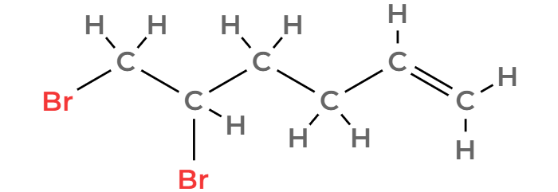
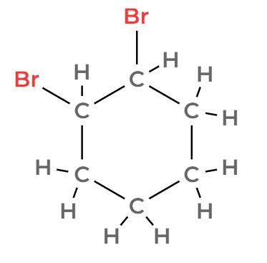

(-1 mark for minor errors)
Total | 4

Question 32 (7 marks)

(a) Identify the carbohydrate / sweetener that exhibits the strongest interactions with the stationary phase. Justify your choice. (3 marks)

Description | Marks
Fructose | 1
Recognition that strong interactions with the stationary phase would results in slow movement through the column. | 1
Recognition that fructose has the longest retention time. | 1
Total | 3

(b) Identify which chromatogram (A, B or C) is likely to represent plain yoghurt. Justify your answer. (2 marks)

Description | Marks
C | 1
Less sweeteners present / No fructose (from fruit) / No glucose (from plants) / No sucrose (sugar). | 1
Total | 2

(c) Identify which chromatogram (A, B or C) represented the yoghurt with the lowest concentration of galactose. (1 mark)

Description | Marks
A | 1
Total | 1

(d) Using the calibration curve above, determine the concentration of galactose, in parts per million, in this yoghurt sample. (1 mark)

Description | Marks
600 ppm (allow ± 125 ppm) | 1
Total | 1

Question 33 (6 marks)

(a) Define an acid according to the Arrhenius theory. (1 mark)

Description | Marks
Recognition that acids produce H⁺ ions in solution. | 1
Total | 1

(b) Define the term ‘weak’ as it relates to the nature of an acid. (1 mark)

Description | Marks
Recognition that weak acids undergo partial ionisation. | 1
Total | 1

(c) Write an equation which illustrates acetylsalicylic acid behaving as a weak acid. (2 marks)

Description | Marks
C₉H₈O₄(aq) ⇌ C₉H₇O₄⁻(aq) + H⁺(aq)
Correct species | 1
Double arrow | 1
Total | 2

(d) If two acetylsalicylic acid tablets were dissolved in 325 mL of water and the resulting solution had a pH of 3.6, calculate the moles of hydrogen ions in the solution. (2 marks)

Description | Marks
c(H⁺) = 10^{-pH}  = 2.51 x 10⁻⁴ mol L⁻¹ | 1
n(H⁺) = 2.51 x 10⁻⁴ x 0.325  = 8.16 x 10⁻⁵ mol | 1
Total | 2

Section Three: Extended answer 40% (69 marks)

Question 35 (17 marks)

(a) Label the identity of the residue and the filtrate in the boxes on the diagram above. Include state symbols for each. (2 marks)

Description | Marks
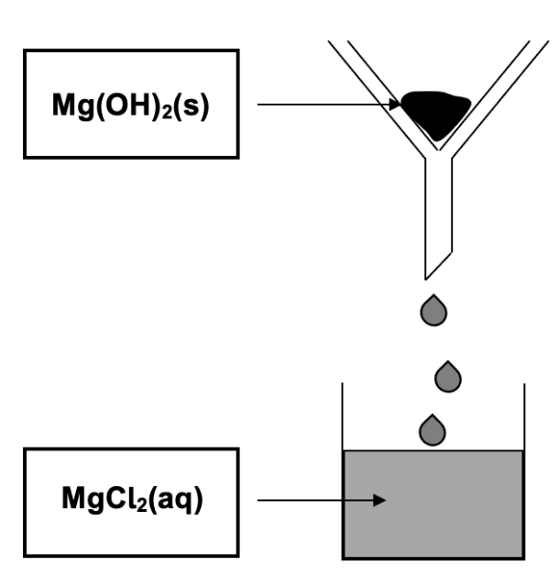  Award 1 mark per correct box. State symbols must be shown. | 2
Total | 2

(b) Write a balanced molecular equation for the reaction that would take place. (2 marks)

Description | Marks
Mg(OH)₂(s) + 2 HCl(aq) → MgCl₂(aq) + 2 H₂O(l)
Correct species | 1
Correct balancing | 1
Total | 2
Note: award full marks for balanced ionic equation (molecular requested to aid comprehension of part (d))

(c) Calculate the mass of compound B in the filtrate. (2 marks)
Description | Marks
n(Mg²⁺ in filtrate) = 0.121 x 0.115  = 0.013915 mol  = n(MgCl₂) | 1
m(MgCl₂) = 0.13915 x 95.21  = 1.32485 g | 1
Total | 2

(d) Calculate the volume of HCl(aq) that would be required to react with all of the residue. (4 marks)
Description | Marks
m(Mg(OH)₂) = 2.91 – 1.32485  = 1.5852 g | 1
n(Mg(OH)₂) = 1.5852 / 58.326  = 0.027177 mol | 1
n(HCl required) = 2 x n(Mg(OH)₂)  = 0.054355 mol | 1
V(HCl) = 0.054355 / 0.274  = 0.198 L | 1
Total | 4

(e) Calculate the concentration of chloride ions present in this final mixture. (4 marks)

Description | Marks
n(Cl⁻ from MgCl₂) = 2 x n(Mg²⁺ in filtrate) from part (c)  = 0.02783 mol | 1
n(Cl⁻ from HCl) = n(HCl required) from part (d)  = 0.054355 mol | 1
n(Cl⁻ total) = 0.02783 + 0.054355  = 0.082185 mol | 1
c(Cl⁻) = 0.082185 / 0.313  = 0.263 mol L⁻¹ | 1
Total | 4

(f) Draw a labelled diagram, showing the predominant forces acting between the chloride ions and the surrounding water molecules in this mixture. (3 marks)

Description | Marks
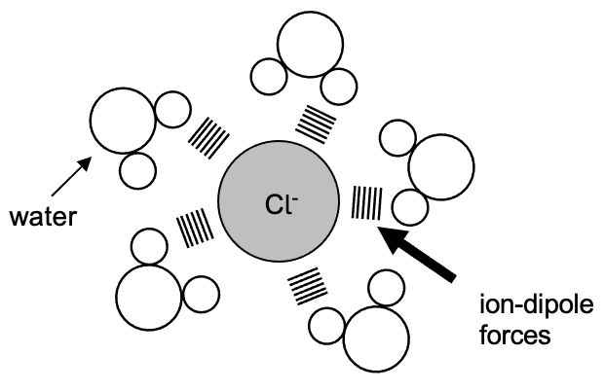

Water molecule and Cl⁻ ion clearly drawn or labelled | 1
Ion-dipole forces labelled | 1
Water molecules oriented correctly towards the Cl⁻ ion | 1
Total | 3

Question 36 (17 marks)

(a) Complete the following table by drawing Lewis structures, and stating the shape of both the hypochlorous acid and nitrogen trichloride molecules. (4 marks)

Description | Marks
Lewis structure diagram Shape  HOCl v-shaped / bent  NCl₃ pyramidal  Award 1 mark per correct cell. | 4
Total | 4

(b) Briefly outline the valence shell electron pair repulsion (VSEPR) theory, and describe how it can be applied to predict each of the shapes in part (a). (4 marks)

Description | Marks
Recognition that VSEPR involves repulsion between electron pairs. | 1
Recognition that this repulsion occurs between both bonding and non-bonding electron pairs (around the central atom). | 1
Recognition that HOCl has 2 bonding and 2 non-bonding pairs of electrons around the central atom (and is therefore v-shaped). | 1
Recognition that NCl₃ has 3 bonding and 1 non-bonding pairs of electrons around the central atom (and is therefore pyramidal). | 1
Total | 4

(c) Explain, in terms of intermolecular forces, why the boiling point of NCl₃ is higher than that of NH₃. (4 marks)

Description | Marks
Recognition that NCl₃ exhibits dispersion and dipole-dipole forces, whilst NH₃ exhibits dispersion, dipole-dipole forces and hydrogen bonding. | 1
Recognition that NCl₃ has a greater M and therefore greater strength of dispersion forces. | 1
Recognition that the sum of intermolecular forces is greater in NCl₃. | 1
Recognition that a greater quantity of heat is required to disrupt the bonding in NCl₃ (resulting in a higher boiling point). | 1
Total | 4

(d) Explain, in terms of intermolecular forces, why NCl₃ and NH₃ display such different solubilities in water. (5 marks)

Description | Marks
Recognition that NH₃ and H₂O both exhibit hydrogen bonding (in addition to dispersion and dipole-dipole forces). | 1
Recognition that NH₃ and H₂O can form new hydrogen bonds when mixed. | 1
Recognition that the energy released in the formation of these new hydrogen bonds is sufficient to overcome the existing intermolecular forces within the H₂O and NH₃ (and thus dissolving occurs). | 1
Recognition that NCl₃ is less polar than NH₃.  or  Recognition that NCl₃ exhibits predominantly dispersion forces.  or  Recognition that NCl₃ does not exhibit hydrogen bonding. | 1
Recognition that formation of new forces between NCl₃ and H₂O would be minimal (and thus dissolving does not occur).  or  Recognition that the energy released when new forces form between NCl₃ and H₂O is not sufficient to overcome the existing intermolecular forces within H₂O and NCl₃ (and thus dissolving does not occur). | 1
Total | 5

Question 37 (19 marks)

A chemistry teacher gave her class four separate solutions labelled A, B, C and D. The identities of the solutions were;

- 0.15 mol L⁻¹ HNO₃(aq)
- 0.15 mol L⁻¹ K₂CO₃(aq)
- 0.15 mol L⁻¹ Ba(OH)₂(aq)
- 0.15 mol L⁻¹ Na₂SO₃(aq)

She then asked the students to design and perform an investigation that would correctly identify A, B, C and D.

The students decided to mix a small amount of each solution with each of the other three solutions. They drew up a table and recorded their results. The initial data they collected is shown below.

 | A | B | C | D
A |  | white precipitate formed | no change observed | no change observed
B |  |  | colourless gas produced | no change observed
C |  |  |  | colourless gas produced
D

a) Which two solutions must have been mixed to produce the white precipitate? Write a balanced ionic equation for this reaction, include states. (4 marks)

- K₂CO₃ (1)
- Ba(OH)₂ (1)
- Ba²⁺(aq) + CO₃²⁻ (aq) BaCO₃ (s) (2)
Ionic – (1 mark), balanced – (1 mark)
Balanced molecular 1 mark maximum.

Two different solution combinations (C + D and B + C) produced colourless gases.

b) Write balanced chemical equations showing how each of these gases was produced. (7 marks)
2 HNO₃(aq) + K₂CO₃(aq) → 2 KNO₃(aq) + CO₂(g) + H₂O(l)
(1 mark) (1 mark) Products (1 mark) Balanced (1 mark)

OR 2 H⁺(aq) + CO₃²⁻(aq) → CO₂(g) + H₂O(l)

2 HNO₃(aq) + Na₂SO₃(aq) → 2 NaNO₃(aq) + SO₂(g) + H₂O(l)
(1 mark) Products (1 mark) Balanced (1 mark)

OR 2 H⁺(aq) + SO₃²⁻(aq) → SO₂(g) + H₂O(l)

One group of students had noted an additional observation which they shared with the class.
“The gas produced from the reaction between C + D had a pungent odour.”

c) Identify each of the four original solutions. (4 marks)

Solution A: barium hydroxide Ba(OH)₂

Solution B: potassium carbonate K₂CO₃

Solution C: nitric acid HNO₃

Solution D: sodium sulfite Na₂SO₃

d) Define ‘acids’ and ‘bases’ according to the Arrhenius theory. Give an example of each and give any necessary equations. (4 marks)

- Acids produce H⁺(aq) in aqueous solution.
- Any reasonable equation:
H₂SO₄ 2H⁺ + SO₄²⁻

- Bases produce OH⁻(aq) in aqueous solution.
- Any reasonable equation:
NaOH Na⁺ + OH⁻

Question 38 ( marks)

(a) State three (3) observations that would be noted as this reaction took place. (3 marks)

Description | Marks
Black solid dissolves | 1
Blue solution forms | 1
Effervescence | 1
Total | 3

(b) Calculate the concentration of nitric acid required, to ensure all the copper(II) sulfide reacts. (4 marks)

Description | Marks
m(CuS) = 93.3 / 100 x 612 x 10³  = 570996 g | 1
n(CuS) = 570996 / 95.61  = 5972.14 mol | 1
n(HNO₃) = 8 / 3 x n(CuS)  = 15925.698 mol | 1
c(HNO₃) = 15925.698 / 6500  = 2.45 mol L⁻¹ | 1
Total | 4

(c) Calculate the concentration of the copper (II) sulfate, in gL⁻¹ in the final solution.
Assume the volume of the final solution is 6500 L. (3 marks)

Description | Marks
n(CuSO₄) = 3 / 3 x n(CuS)  = 5972.14 mol | 1
m(CuSO₄) = 5972.14 x 159.61  = 953212.7556 mol | 1
c(CuSO₄) = m / V  = 953212.7556 / 6500  = 146.65 g L⁻¹ | 1
Total | 3

(d) Calculate the volume of nitrogen monoxide formed at STP. (2 marks)

Description | Marks
n(NO) = 3 / 3 x n(CuS)  = 15925.698 mol | 1
V(NO) = 15925.698 x 22.71 at STP  = 631672.605 L | 1
Total | 2

(e) Draw electron dot diagrams (Lewis structures) and state the shape of the molecules/ions below. (4 marks)

Name of molecule | Lewis Structure diagram showing all bonds and electrons | Name of shape of the molecule
Sulfate ion | 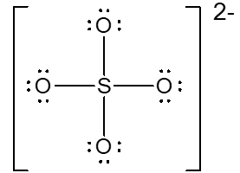 | Tetrahedral
Water | 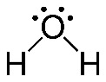 | V shaped (bent)

